Azure small TOPICS

- Networking in Azure
- Availability Zone
- Availability Set
- Monitor Tool
- 3 Tier Architecture
- Health Probe
- CDN – Content Delivery Network
- WAF – Web Application Firewall
- Git and GitHub
- Blue Green Deployment Strategy
- Hub and Spoke
- Service End Point
- Private End Point
- MFA – Multi Factor Authentication

At 4th topic networking
- NETWORKING IN AZURE
- In Microsoft Azure, networking refers to the set of services and resources that allow Azure resources (like virtual machines, databases, and applications) to communicate securely and efficiently — both with each other and with the internet, on-premises networks, or other cloud environments.

Key Concepts in Azure Networking
- Virtual Network (VNet)
  - The core building block of Azure networking.
  - Think of it like your own private network in the cloud.
  - You can divide it into subnets, control traffic using Network Security Groups (NSGs), and connect it to other networks.
  - Similar to a traditional on-premises network but hosted in Azure.

- Subnets
  - Logical divisions within a VNet.
  - Help organize and isolate workloads (e.g., web servers, databases, etc.).

- Network Security Group (NSG)
  - A firewall-like feature that controls inbound and outbound traffic to Azure resources based on rules (source/destination IP, port, protocol).

- Azure Load Balancer
  - Distributes incoming network traffic across multiple VMs or services to ensure high availability and scalability.

- Azure Application Gateway
  - A layer 7 (HTTP/HTTPS) load balancer that includes Web Application Firewall (WAF) for protection against web attacks.

- Azure Firewall
  - A fully managed, cloud-based network security service that protects your Azure Virtual Network resources.

- Azure VPN Gateway
  - Connects your on-premises network to Azure through a secure VPN tunnel over the internet.

- Azure ExpressRoute
  - A private, high-speed, dedicated connection between your on-premises network and Azure (not over the public internet).

- Azure DNS
  - A service to host and manage your domain names in Azure.

- Private Link & Service Endpoints
  - Allow secure, private access to Azure services (like Azure Storage or SQL Database) without going over the public internet.

- Azure Bastion
  - Provides secure, browser-based RDP/SSH access to virtual machines — no public IPs needed.

- Peering
  - Connects two VNets together so they can communicate privately, even if they are in different regions.

- Common Use Cases
- Building secure hybrid networks (connecting on-premises to Azure)
- Hosting web applications with load balancing and firewalls
- Creating isolated environments for development, testing, or production
- Implementing zero-trust security models

Types by Cloud Provider
This is the most common way to differentiate "types" of NSGs. While the core concept is the same, each major cloud provider has its own name, implementation, and specific features.
Cloud Provider | Service Name | Primary Scope | Key Characteristics
Microsoft Azure | Network Security Group (NSG) | Subnets and Network Interfaces (NICs) | Stateful. Can be applied to both an entire subnet (affecting all resources within it) or to an individual NIC (for granular, per-instance control). Has Basic and Standard SKUs.
Amazon Web Services | Security Group (SG) | Instances (EC2) and other ENIs | Stateful. Primarily attached to network interfaces (like an EC2 instance). It's an "allow-only" list (all traffic is denied by default unless a rule allows it). Return traffic is automatically allowed.
Google Cloud Platform | VPC Firewall Rules | VPC Networks and Instances (via tags) | Stateful. Applied at the VPC network level but uses target tags or service accounts to apply to specific instances. Supports both "allow" and "deny" rules.

NSGs vs. Other Cloud Security Services (Important Distinctions)
It's also helpful to understand how NSGs differ from other related security tools. This often causes confusion.
Service | Azure NSG | Azure Firewall | AWS Security Group | AWS Network ACL
Type | Network Layer (L4) | Application & Network Layer (L4/L7) | Network Layer (L4) | Network Layer (L4)
Scope | Subnet / NIC | Subnet / VPC Hub | Instance / ENI | Subnet
State | Stateful | Stateful | Stateful | Stateless
Key Features | Port/Protocol filtering | Threat Intelligence, URL/FQDN filtering, IDS/IPS | Simple, instance-level firewall | Subnet-level "traffic cop"
Use Case | Basic port protection, internal network segmentation. | Centralized, advanced security for entire VPC. | Primary security for EC2 instances. | Secondary, subnet-wide security boundary.

- AVAILABILITY ZONE
- An Availability Zone (AZ) is a physically separate and independent data center (or group of data centers) within a cloud region that provides high availability, fault tolerance, and scalability for cloud resources.
- Each one being an isolated data center with its own power, cooling, and networking.
- Availability Zones are designed so that if one data center (AZ) fails due to a power outage or disaster, the others keep running.
You can deploy your applications across multiple AZs to ensure:
  - High availability
  - Disaster recovery
  - Low-latency failover

- AVAILABILITY SET
- An Availability Set is a logical grouping feature that helps ensure your virtual machines (VMs) stay available and resilient to outages.
- An Availability Set is a configuration setting for Azure VMs that distributes them across multiple fault domains (FDs) and update domains (UDs) within a single Azure datacenter.

Key Concepts
- Fault Domain (FD)
- A fault domain is essentially a group of hardware (like servers, power, and network switches) that share a common physical infrastructure.
- If one fault domain fails (e.g., power outage, hardware fault), only the VMs in that domain are affected.
- Azure typically provides up to 3 fault domains per region.
- Update Domain (UD)
- Update domains are logical groups that determine how planned maintenance (like software or firmware updates) is rolled out.
- Azure updates one UD at a time, ensuring VMs in other UDs remain running during maintenance.
- There are typically up to 20 update domains available.

Benefits | 🚫 Limitations
High availability — at least one VM remains running during hardware or maintenance events. | Works only within a single datacenter (not across regions).
99.95% SLA — Azure guarantees a 99.95% uptime for VMs in an Availability Set. | Does not provide automatic failover — you handle application-level redundancy.
Better resiliency against planned and unplanned downtime. | Newer deployments often use Availability Zones instead, which offer higher resilience by spanning multiple datacenters.

Summary Table
Concept | Description
Purpose | Keep VMs available during hardware or maintenance failures
Scope | Single datacenter
Fault Domains | Physical separation (e.g., different racks/power)
Update Domains | Logical separation for maintenance updates
SLA | 99.95% for VMs in an Availability Set

- MONITORING TOOL
- A monitoring tool refers to a set of services and features that help you track, analyze, and manage the performance, health, and reliability of your cloud resources, applications, and infrastructure.

- The main monitoring service in Azure is called Azure Monitor.

- What is Azure Monitor?
- Azure Monitor is the centralized monitoring platform in Azure.
It collects, analyzes, and visualizes telemetry data (logs, metrics, and traces) from:
  - Azure resources (VMs, databases, etc.)
  - On-premises environments
  - Applications
  - Containers and Kubernetes clusters

It helps you understand what’s happening in your environment and proactively respond to issues.

Components of Azure Monitor
Component | Purpose | Example Use
Metrics | Real-time numerical data that shows performance | CPU utilization, memory usage, network I/O
Logs | Detailed event and diagnostic data | VM crash logs, audit trails, request failures
Application Insights | Monitors applications for performance and usage | Tracks app performance, dependencies, exceptions
Log Analytics | Query and analyze log data using Kusto Query Language (KQL) | Find root cause of issues
Alerts | Notifies when conditions are met | CPU > 90%, failed login attempts, etc.
Workbooks | Custom dashboards for visualization | Display key metrics and charts
Azure Monitor for VMs | Monitors VM performance and dependencies | Detects VM bottlenecks
Azure Monitor for Containers | Monitors Kubernetes and container workloads | Monitors AKS cluster health
Network Watcher | Monitors network performance and connectivity | Track latency, packet loss, etc.

How Azure Monitor Works
- Data Collection – Gathers metrics and logs from Azure resources, OS-level agents, and applications.
- Data Analysis – Correlates and analyzes the data in real time.
- Alerting – Generates alerts when thresholds are exceeded.
- Visualization – Displays data in dashboards (Workbooks, Power BI, etc.).
- Automation – Integrates with Logic Apps or Azure Automation to automatically fix issues.

Other Related Azure Monitoring Tools
Tool / Service | Purpose
Azure Service Health | Tracks service issues and maintenance events in Azure itself
Azure Advisor | Gives performance, cost, and reliability recommendations
Azure Sentinel (now Microsoft Defender for SIEM) | Security monitoring and threat detection
Network Performance Monitor | Monitors network connectivity and latency
Azure Log Analytics Workspace | Central storage for logs collected from Azure Monitor

- WHAT IS 3 TIER ARCHITECTURE
- 3-tier architecture in cloud computing is a software design model that separates an application into three logical layers
- It’s a way to build and host applications in the cloud by dividing them
  - Presentation – User interface (front end)
Handles the user interface — what users see and interact with
  - Application – Business logic (middle tier)
Processes business logic, application rules, and handles communication between the presentation and data tiers.
  - Data – Database (back end)
Stores, retrieves, and manages data.
and deploys each layer using cloud-based services.

Each tier runs on separate cloud resources, allowing for independent scaling, management, and security, while improving flexibility and performance.

- HEALTH PROBE
- Regularly monitor backend health using:
  - Protocol: HTTP or HTTPS
  - Path: e.g., /health
- Interval: configurable (e.g., every 30 seconds)
If a backend fails health checks, the gateway automatically stops routing traffic to it until it recovers.

CDN
- WAF – WEB APPLICATION FIREWALL
The WAF is one of the key advantages of Application Gateway.
- It helps protect against:
  - SQL Injection, Cross-site scripting (XSS), Command injection, HTTP protocol violations, OWASP Top 10 vulnerabilities

- What is GITHUB
- What is Git
- What it is: A version control system (VCS).
- Who made it: Created by Linus Torvalds in 2005.
- What it does:
  - Tracks changes in code.
  - Lets you go back to previous versions.
  - Allows branching and merging.
- Where it runs: On your local computer (offline).
- Use without internet: Yes.
Analogy: Git is like a tool that keeps snapshots of your project.

- GitHub is an online platform used for storing, sharing, and collaborating on code.
- It’s built around Git, a version-control system that helps developers track changes to their projects over time.

Key things GitHub is used for:
- Version control: Keep track of every change made to code.
- Collaboration: Multiple people can work on the same project without overwriting each other’s work.
- Open-source projects: Many public software projects (like React, Linux tools, etc.) are hosted on GitHub.
- Issue tracking: Report bugs, suggest features, and manage project tasks.
- Code review: Teams can review each other’s code using pull requests.

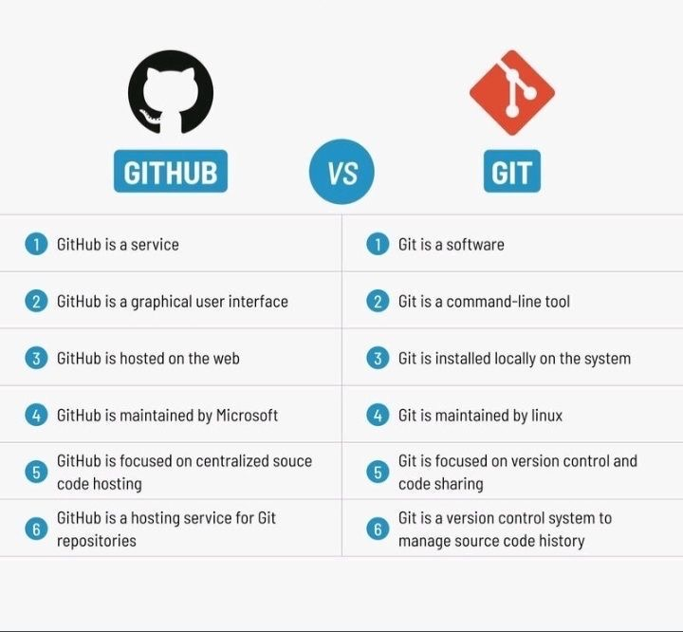
Concepts you’ll see on GitHub:
- Repository (repo): A project folder containing all your code.
- Commit: A saved change in your code.
- Branch: A separate workspace for making changes without affecting the main project.
- Pull Request: A request to merge changes into the main project after review.
- Fork: A copy of someone’s repo that you can modify independently.

Difference between Git and GitHub
Feature | Git | GitHub
Type | Version control software | Online hosting/service
Usage | Track changes locally | Share, collaborate, store repos
Requires internet? | No | Yes
Who uses it | Developers managing code | Individuals & teams collaborating
Command-line? | Yes | Optional (website + CLI)

- What is Blue Green Deployment Strategy
- Blue-Green Deployment is a software release strategy that reduces downtime and risk by running two identical production environments:
- Blue = current live environment
- Green = new version of your application

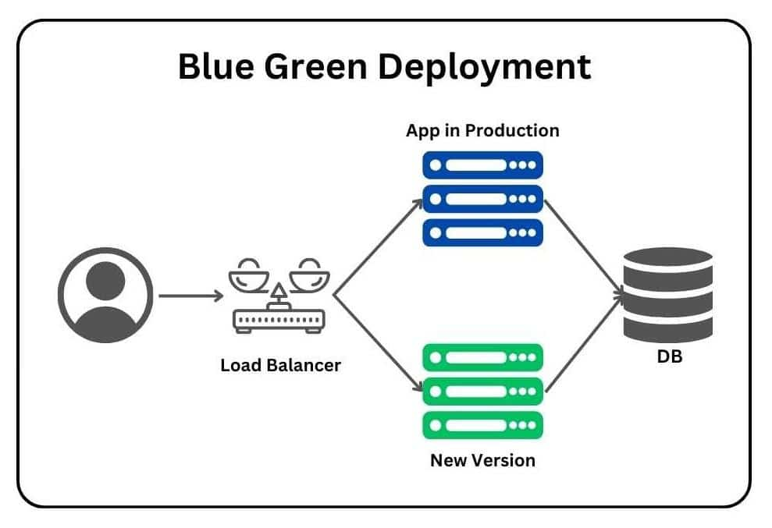
Only one environment is live at a time.

- How Blue-Green Deployment Works
- Two environments exist: Blue (live) and Green (idle)
- Blue is serving real users.
- Green has the new version of your app but isn’t receiving traffic yet.

- Deploy new version to Green
- You fully test the new release in the Green environment without affecting users.

- Switch traffic from Blue → Green
- Once everything works on Green, a router/load balancer (like Nginx, AWS ALB, Kubernetes service) switches traffic to Green instantly.

- Blue becomes backup
- If something goes wrong with the new release, you can quickly roll back by switching traffic back to Blue.

- Benefits of Blue-Green Deployment
Advantage | Explanation
Zero downtime | Users never see the deployment or updates.
Fast rollback | Revert to Blue instantly if Green fails.
Reduced risk | Testing on Green avoids breaking production.
No user disruption | Live traffic switches in seconds.

- Drawbacks
Limitation | Why it matters
Double infrastructure needed | Maintaining two full environments can be costly.
Data synchronization issues | Databases shared between Blue & Green must stay in sync.
Not ideal for huge stateful systems | Works best when application is stateless or handles migrations well.

- Where Blue-Green Is Used
- AWS (Elastic Beanstalk, ECS, Lambda with aliases)
- Kubernetes (using services + selectors)
- Cloud Foundry
- CI/CD pipelines (GitHub Actions, Jenkins, GitLab CI)

- What is HUB AND SPOKE
- Hub and Spoke is an architectural model (used in networking, cloud, transportation, logistics, etc.) where a central hub connects to multiple spokes.
- The hub acts as the main control point, and the spokes depend on it for communication or routing.

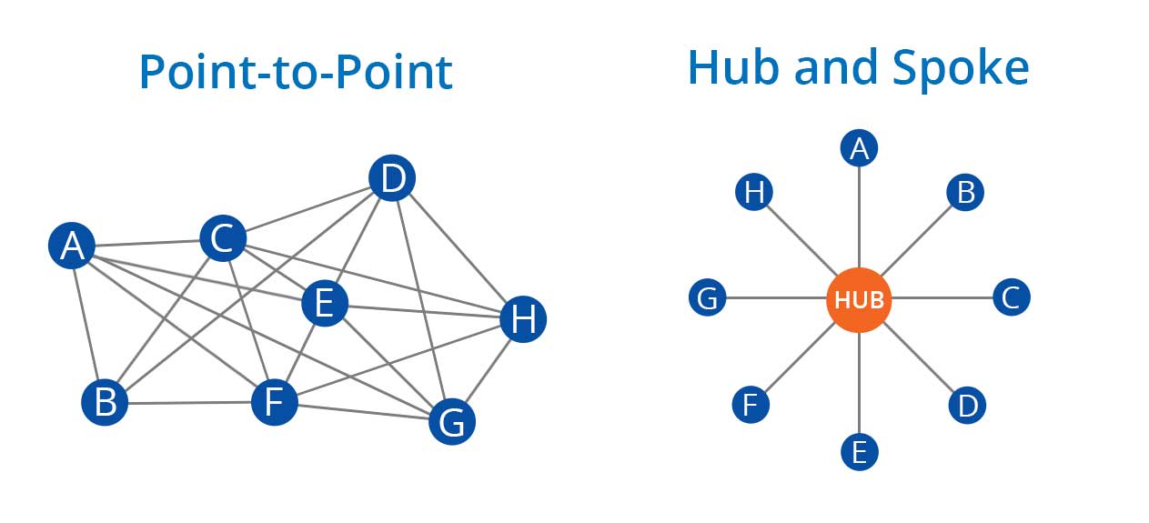

- Hub and Spoke Model (Simple Explanation)
- Hub → central node
- Spokes → peripheral nodes connected to the hub

All communication flows from spoke → hub → spoke instead of directly between spokes.

- Why Use Hub and Spoke?
It provides:
- Centralized control
- Better security and monitoring
- Simplified management
- Isolation between spokes

- Pros and Cons
Advantages | Disadvantages
Centralized management | Hub can become a bottleneck
Easy monitoring and security | If hub fails → entire system impacted
Cost-effective (shared services in hub) | More routing complexity (in IT networks)
Scalable — add more spokes anytime

- Service End Point :
An Azure Service Endpoint is a feature of Azure Virtual Network (VNet) that allows resources inside a subnet to connect to supported Azure services over the Azure backbone network, instead of going through the public internet.

Purpose | Explanation
🔐 Security | Restrict Azure services to selected VNets/subnets
🌐 Private Azure Backbone | Traffic stays on Microsoft's Azure network
🚫 Reduce Public Exposure | You can restrict access to the service's public endpoint
🛡️ Network Filtering | Storage, SQL, Key Vault etc. can allow only specific subnets
⚡ Simple Configuration | Easier to configure than Private Endpoint

- Service Endpoints can be used with supported services such as:
- Azure Storage
- Azure SQL Database
- Azure Key Vault
- Azure Service Bus
- Azure Event Hubs
- Azure Cosmos DB
- Azure App Service in supported scenarios

- Private End Point :
- An Azure Private Endpoint is a network interface (NIC) with a private IP address from your Azure VNet that connects privately to an Azure PaaS service such as Azure Storage, Azure SQL, Key Vault, Cosmos DB, etc.
Or
- Private Endpoint allows you to access an Azure service using a private IP address inside your VNet instead of accessing it through a public endpoint.

- 🎯 Uses of Private Endpoint
- 🔐 Secure access to Azure PaaS
- 🚫 Disable public access
- 🌐 Private IP address
- 🛡️ Reduce internet exposure

- 🔥 Private Endpoint vs Service Endpoint
- This is a very important Azure interview question.
Feature | Service Endpoint | Private Endpoint
Private IP for service | ❌ No | ✅ Yes
Private IP in VNet | ❌ | ✅
Azure backbone | ✅ | ✅
Public endpoint involved | Yes | Can be disabled
Network interface (NIC) | ❌ | ✅
DNS configuration | Usually simpler | Important
Network isolation | Good | Better
Typical use | Simple subnet restriction | Strong private connectivity

      - Easy memory trick
- Service Endpoint : "My subnet is allowed to access the Azure service."
- Private Endpoint : "Give my Azure service a private IP inside my VNet."

    - Life cycle management
- Cloud Life Cycle Management is the process of automatically managing cloud resources or data throughout their entire life, from creation to modification, archival, and finally deletion.

Or

- Life Cycle Management = Automatically decide what happens to data/resources as they become older or are no longer needed.

- 🎯 Why is Lifecycle Management used?
Use | Explanation
💰 Cost Optimization | Move old data to cheaper storage tiers
🤖 Automation | Automatically perform actions based on age/conditions
🗄️ Data Archiving | Move rarely accessed data to archive storage
🧹 Automatic Cleanup | Delete data that is no longer required
📦 Storage Management | Keep frequently used data in appropriate storage tiers
🔐 Compliance | Retain data for a required period before deletion
⚡ Performance | Keep frequently accessed data in faster storage tiers

- 🆚 Lifecycle Management vs Backup
Lifecycle Management | Backup
Manages data based on rules/time | Creates copies for recovery
Moves data between storage tiers | Protects against data loss
Can automatically delete old data | Keeps recovery points
Mainly cost/data management | Mainly disaster recovery

    - Data migration
- Data migration is the process of moving data from one storage system, application, database, or environment to another.
- 📦 Data Transfer – Moves data from an old system to a new system.
- ☁️ Cloud Migration – Moves on-premises data to cloud platforms like AWS, Azure, or GCP.
- 🔄 System Upgrade – Used when migrating from an old database/storage system to a newer one.
- 🔐 Security & Integrity – Ensures data remains secure, accurate, and complete during migration.
- 💰 Cost & Performance – Can improve scalability, availability, performance, and reduce infrastructure costs.
      - Example : On-Premises Database → Azure SQL Database = Data Migration.

    - Azure Data box :
- Azure Data Box is a Microsoft service used to physically transfer large amounts of data between your on-premises environment and Azure.
- Instead of transferring terabytes of data over the internet,
- Microsoft provides a secure physical device that you can load with data and send back to Azure.
- Key Points
- 📦 Physical Data Transfer – Microsoft provides a Data Box device to copy your data.
- 🚀 Large Data Migration – Useful for migrating TBs or PBs of data when internet transfer is slow.
- 🔐 Secure – Data is protected during transportation and the device uses security controls to protect the data.
- ☁️ Upload to Azure – After Microsoft receives the device, your data is transferred into Azure storage.
- 💰 Saves Time & Bandwidth – Useful when transferring huge datasets over the internet would take too long or consume significant network bandwidth.

- Azure Data Box is a physical data-transfer service from Microsoft that helps organizations migrate large amounts of data to or from Azure when transferring the data over the network is impractical or too slow.

    - Test Failover
- Test Failover is a process used in disaster recovery (DR) to verify that your backup or replicated system can successfully run during a disaster without affecting the production environment.
- 🧪 DR Testing – Checks whether your disaster recovery setup actually works.
- 🖥️ Creates Test Environment – Starts a test version of the replicated VM/application.
- 🚫 Doesn't Affect Production – Production workloads continue running normally.
- ✅ Validates Recovery – Verifies applications, networking, databases, and services after recovery.
- 🔧 Finds Problems Early – Helps identify configuration, networking, or replication issues before a real disaster.

- Test Failover vs Actual Failover
Test Failover | Actual Failover
🧪 For testing | 🚨 During real disaster
Production continues | Production may be unavailable
Uses test recovery environment | Recovers production workload
No production disruption | Business service is switched to DR

- Test failover is a disaster-recovery testing operation that validates whether replicated workloads can be successfully recovered in a secondary environment without impacting the production environment.

    - Recovery Service Vault
- An Azure Recovery Services Vault is a storage and management location in Azure used to store backup data and manage disaster recovery operations.
- It is commonly used with Azure Backup and Azure Site Recovery (ASR).
- 💾 Backup – Stores recovery points for Azure VMs, files, databases, etc.
- 🔄 Disaster Recovery – Used by Azure Site Recovery to manage VM replication and recovery.
- ♻️ Restore Data – Helps restore VMs, files, and other protected resources after data loss.
- 🧪 Test Failover – Supports testing your DR setup without affecting production.
- 🛡️ Centralized Management – Provides one place to manage backup and recovery operations.

- Azure Recovery Services Vault is a centralized Azure resource used to store backup recovery points and manage backup and disaster recovery operations through Azure Backup and Azure Site Recovery.

- Image-level backup: Backs up the entire disk/system image, including OS, applications, configurations, and data.
- File-level backup: Backs up specific files and folders rather than the entire system.

    - Site Recovery & Geo-Replication
- Site Recovery: A disaster recovery service that replicates workloads from a primary site/region to a secondary site/region and enables failover when the primary site has a disaster.
- Geo-Replication: Keeps copies of data/workloads in geographically different Azure regions, so services can be recovered if one region becomes unavailable.

    - DR Drill Activity
- A DR (Disaster Recovery) Drill is a planned practice exercise to test whether the disaster recovery system can successfully recover applications and data during a disaster.
      - Example : Primary Region → Simulate Failure → Failover to DR Region → Verify Application → Failback
- Purpose: To verify RTO, RPO, backups, replication, failover, and application recovery before a real disaster occurs.

    - Azure Hub-and-Spoke
- Hub VNet – A central VNet that provides shared services such as Azure Firewall, VPN Gateway, DNS, and Bastion.
- Spoke VNets – Separate VNets for individual workloads such as Web, Application, and Database environments.
- Peering – Hub and spoke VNets are connected using VNet Peering so resources can communicate.
- Centralized Security – Internet traffic and network security can be controlled centrally through the Hub.
- Scalability – New Spoke VNets can be added without creating direct connections between every VNet.
      - Easy to remember : Hub = Central Network | Spoke = Workload Network

    - Azure Logic Apps
- Azure Logic Apps is a cloud service used to automate workflows and integrate different applications, services, and systems with little or no code.
- Only Paid account works and free trail won’t work
- 🎯 Uses
- 🔄 Workflow Automation – Automatically perform tasks based on triggers and conditions.
- 🔗 Application Integration – Connect Azure services, SaaS applications, databases, APIs, and on-premises systems.
- 📧 Notifications – Send emails, Teams messages, or alerts automatically when an event occurs.
- ⏰ Scheduled Tasks – Run workflows at a specific time or on a recurring schedule.
- 📊 Data Processing – Collect, transform, and move data between different services.

    - Unique points
- Choose server based Operating System
- Win 10/11 for laptops does not work on servers
- Server based operating system for VM

- Private IP : secure and can not be accessed due to local

- For windows to access RDP is used
- For Ubuntu / Linex putty is used

